Learning Management System (LMS) Report

1. Introduction
This report provides the comprehensive analysis of the design, implementation, testing, usability assessment, analysis of measures, tooling strategy, and evaluative outcome of the Learning Management System (LMS) project. The system is implemented as a Java multi-module application, a Spring Boot backend and Java Swing GUI desktop front-end. The backend is responsible for providing the restful endpoints for getting the student enrolment and instructor activity information while the desktop application is responsible for providing a simple user interface to view the enrolment information.

The main goal of the project is to demonstrate the use of the basic software engineering practices in a realistic but tractable academic setting. clear separation of responsibilities, automated testing, user centred refinements, and evidence-based evaluation are highlighted on the journey of endeavour.

2. System Overview and Analysis
The LMS is divided into two modules:
- lms-backend: a Spring Boot REST API
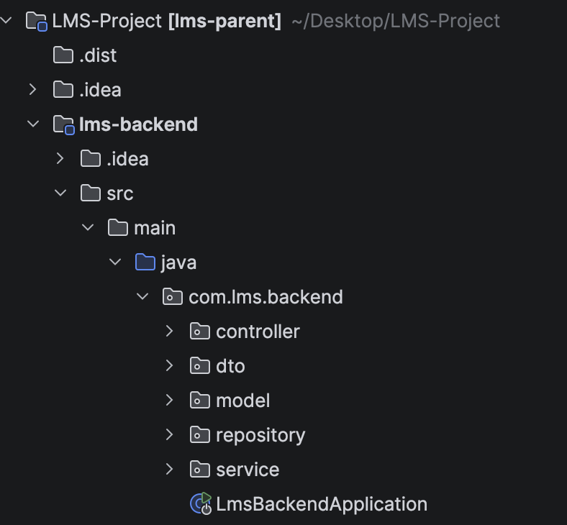

- lms-desktop: a Java Swing desktop client
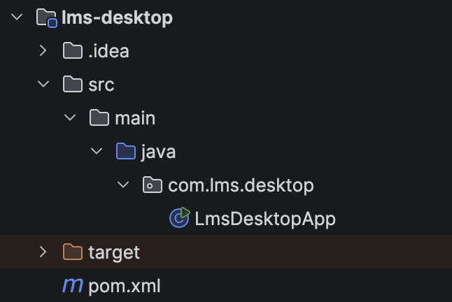
This separation helps in improving the modularity and maintainability of the solution. The backend is responsible for business logic and data acquisition while the desktop client is responsible for user interaction and presentation. Consequently, the design helps in reducing coupling and easing up the independent testing of the business layer from the user interface.

2.1 Backend Architecture

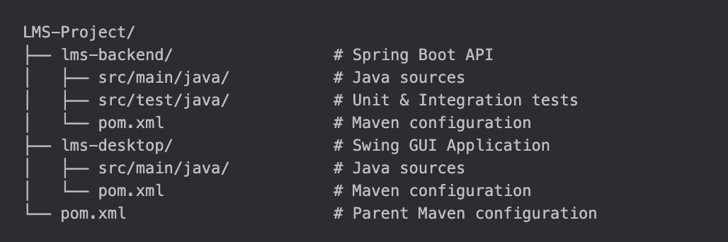
The architecture is well-suited for developing a small information system in that each of the layers has a well-defined responsibility and as such, it promotes separation of concerns and enhanced maintainability. The controller layer handles the request routing, as well as the management of incoming HTTP requests. The service layer wraps the core business logic including filtering, mapping and aggregating business logic. The repository layer hides the persistence mechanism, and the rest of the application is agnostic to the data storage mechanism. Moreover, Data Transfer Objects (DTOs) are used to protect the internal data structures from being unnecessarily exposed, embracing a tidier and controlled interface from one layer to the next one.

The backend currently operates with an in-memory repository hence keeps the system lightweight so you can have rapid development and testing cycles. This way it allows quick tests of application logic without the overhead involved in a database-where the database is set up and maintained. Nevertheless, the lack of persistence means that all information is lost when the application restarts, as the records will be regenerated at the time of the startup of the application. Whilst this limitation is acceptable for an academic prototype a production grade system would require a database backed repository to provide data durability and long-term storage.

2.2 Functional Features
The desktop client focuses on a single core user journey which is to search for a student's enrolments given an identifier and to display the results in a non béton table. Although minimal, it considers usability enhancements, such as validation, visible system status indication, and read only table presentations.

The backend supports the following functionality:
- Fetching of all enrolments of a specific students.
- Getting all the active students who are associated with at least one course.
- The determination of the most active instructor in terms of total number of enrolments
- Retrieval of instructors with no enrolments.

3. Unit Testing

3.1 Testing Scope
• Successful enrollment retrieval
• Empty results
• Instructor fallback behavior
• Filtering invalid enrollments
• Active student identification
• Most active instructor detection
• Handling invalid references
• Instructors with no enrollments
• All instructors active scenario

3.2 Design of Unit Test

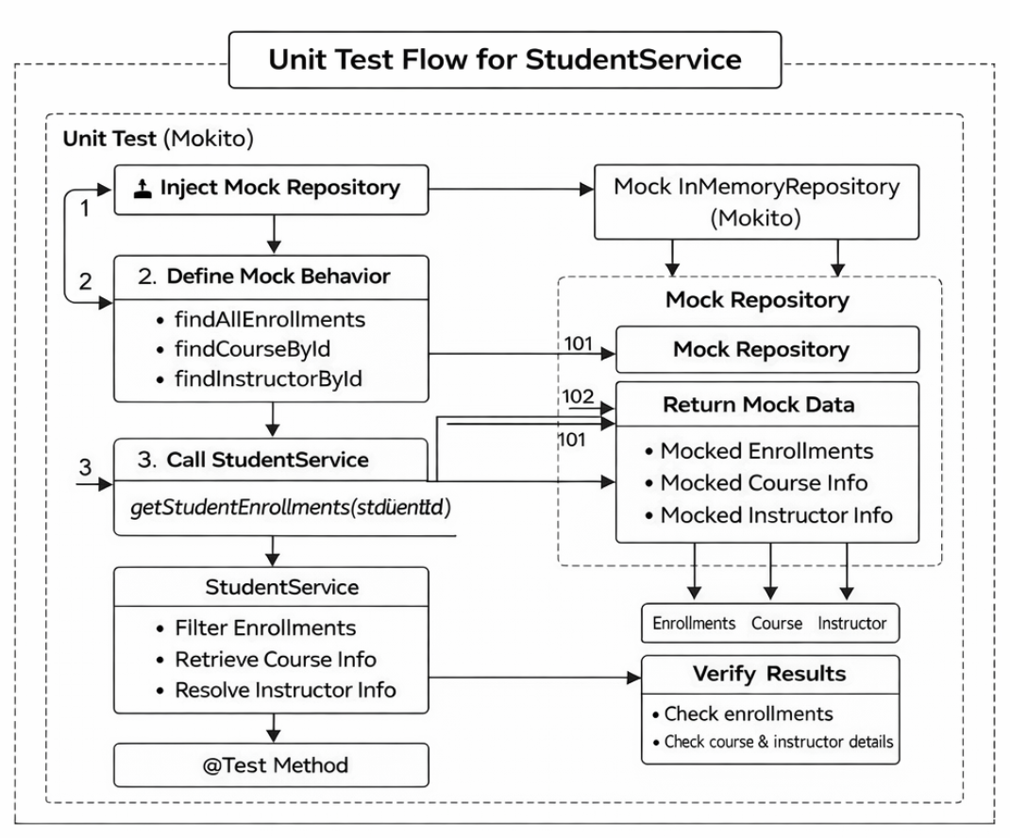

The StudentServiceTest is used to verify the behavior of functionality in the StudentService in isolation wherein the real data persistence layer is replaced with a fake repository. This way it is ensured that the purely service logic is tested without any real dependencies to data storage or other dependencies.

The test procedure starts with the configuration phase: the in-memory version of Mockito starts with the creation of a mocked version of the InMemoryRepository. This mock is injected in to the StudentService, which, for the purpose of this mock the all the invocations on the repository of the service we have will return predefined values instead of any real data.

Within each individual test case, explicit behaviors are outline. For example, for evaluation of enrollment retrieval, the repository is set to provide a list of enrollments, a course and an instructor. These fake responses mimic the conditions of real data.

Upon calling an execution on the method getStudentEnrollments(studentId), the service performs a host of internal operations, including retrieving all of the enrollments, filtering them by the given student ID, mapping each of the enrollments to the corresponding courses, and finally resolving the instructor associated with the course. Should any data element be missing - for instance an instructor - fall back logic is invoked.

The result is then returned back in the form of a list of CourseDTO objects. Assertions are used to verify that the output received is as expected, including correct courses names, instructors names and list sizes.
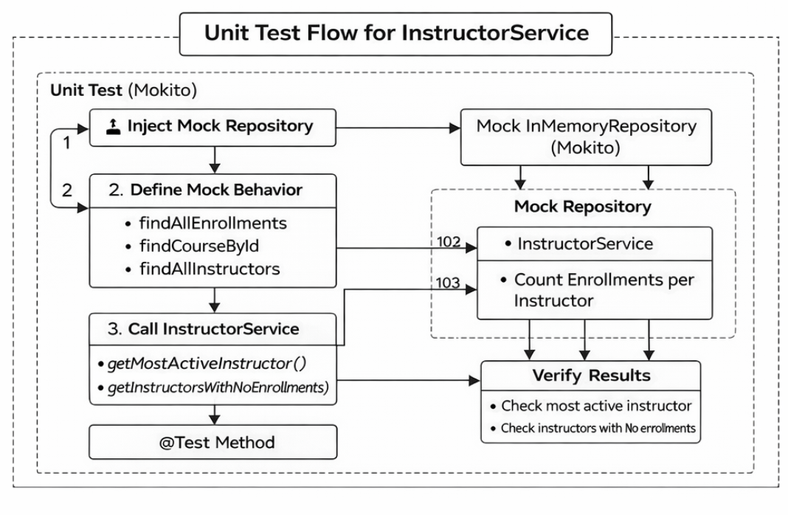
The InstructorServiceTest examines the logic used behind the aggregation and filtration of instructor-related data (in the service layer). Analogus to the tests of the student, mocking is made of the repository, in order to isolate the service layer and have a precise control over the input data, which should result in any behavior observed to be due only to the service implementation.

The test starts by setting up mocked responses for enrollments, courses and instructors. These data sets are carefully designed to simulate a range of scenarios, such as multiple enrollments being spread across multiple courses, the lack of course references, and instructors being rendered devoid of activity.

Upon invocation of the getMostActiveInstructor() method, the service will get all of the enrollments and associates them with their corresponding course. From such courses, the identifier of the instructors is extracted, and enrollment numbers are aggregated by instructor; from the service the instructor with the maximal enrollment number is determined.

In cases where an enrollment has a reference to a non-existent course, the record is simply ignored thereby maintaining data integrity and providing an example of defensive programming within the service logic.

The getInstructorsWithNoEnrollments() method works as follows: it compares the complete list of instructors with the ones that occur in enrollment records. Any instructor that is not in the enrollment set is considered inactive and as such, is returned as part of the result set.
3.3 Unit Test Case and Result
Unit Test for StudentService

Test ID | Test Name | Scenario Description | Input / Setup | Expected Result | Actual Result | Status
UT-01 | testGetStudentEnrollments_  Success | Retrieve enrollments for a valid student with valid course and instructor | Student ID = 1, Course = "Java 101", Instructor = "Dr. Smith" | One enrollment returned with correct course name and instructor name | Enrollment list contains "Java 101" and "Dr. Smith" | Pass
UT-02 | testGetStudentEnrollments_  NoEnrollments | Student has no enrollments | Student ID = 1, repository returns empty enrollment list | Empty list returned | Empty list returned | Pass
UT-03 | testGetStudentEnrollments  _UnknownInstructorFalls  BackToDefaultLabel | Instructor not found for a valid course | Instructor lookup returns empty | Instructor name defaults to "Unknown Instructor" | Instructor name correctly set to "Unknown Instructor" | Pass
UT-04 | testGetStudentEnrollments  _MissingCourseIsIgnored | Enrollment references a non-existent course | Course lookup returns empty | Enrollment ignored, empty result returned | Empty list returned | Pass
UT-05 | testGetActiveStudents_  ReturnsDistinctEnrolled  StudentsOnly | Retrieve only students with at least one enrollment | Students: 10, 11, 12; Enrollments: 10, 11 only | Only students 10 and 11 returned | Students 10 and 11 returned; 12 excluded | Pass
Unit Test Flow for InstructorService

Test ID | Test Name | Scenario Description | Input / Setup | Expected Result | Actual Result | Status
UT-06 | testGetMostActiveInstructor_  ReturnsInstructorWithHighest  EnrollmentCount | Identify instructor with highest number of enrollments | Enrollments mapped to courses 101 and 102; Instructor 1 has 2 enrollments, Instructor 2 has 1 | Instructor with ID = 1 ("Dr. Alice") returned with count = 2 | Correct instructor ("Dr. Alice") returned with enrollment count = 2 | Pass
UT-07 | testGetInstructorsWithNo  Enrollments_ReturnsOnly  InactiveInstructors | Retrieve instructors with zero enrollments | Instructors 1 and 2 have enrollments; Instructor 3 has none | Only Instructor 3 ("Dr. Charlie") returned | Instructor 3 correctly returned | Pass
UT-08 | testGetMostActiveInstructor_  IgnoresMissingCourses | Handle enrollments referencing non-existent courses | One enrollment references missing course (999), one valid course (101) | Missing course ignored; valid instructor returned with correct count | Instructor 1 returned with enrollment count = 1 | Pass
UT-09 | testGetInstructorsWithNo  Enrollments_WhenAllI  nstructorsActive_ReturnsEmptyList | All instructors have at least one enrollment | Single instructor with one enrollment | Empty list returned | Empty list returned | Pass

4. Integration Testing

4.1 Design of Integration Test

4.1.1 Students Integration Test Flow

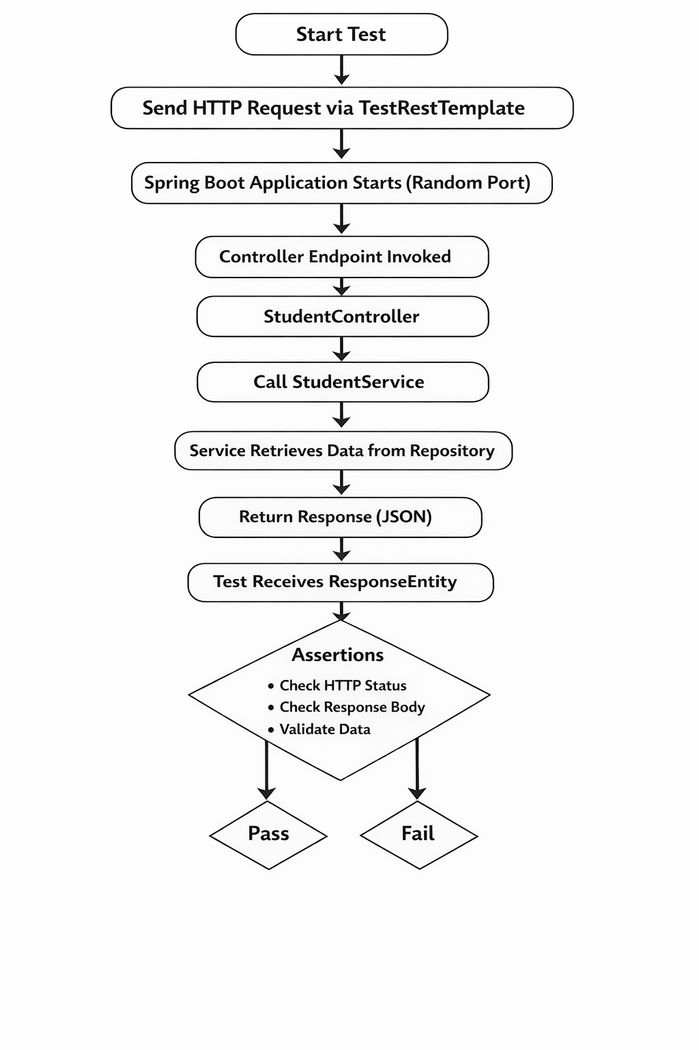
Integration tests verify that the endpoints of the controller handle the HTTP requests and the response from the endpoint is appropriate. Both these tests verify that the API endpoints are functioning as designed to return accurate data using the right status codes. This does prove that there is right integration between the controller layer, service layer and repository layer and the system is working as a whole (Yuan, 2024).

4.1.2 Instructor Intergration Testing Flow

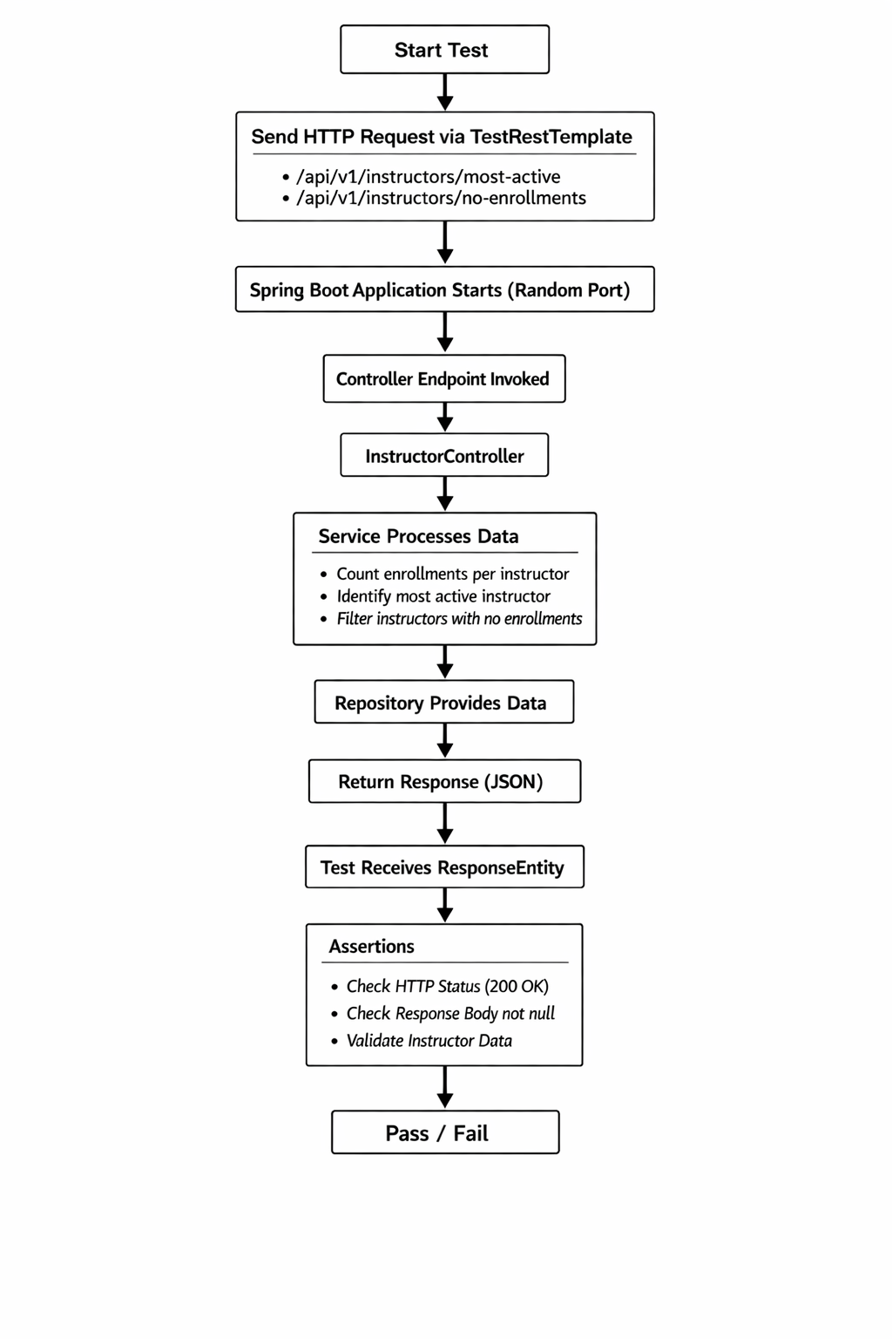

The integration test for the InstructorController includes the test of the entire system flow from the request from the http server to the response from the http server. The test uses TestRestTemplate to make simulated rest calls on the real API of an application running on a random port. When a request is sent, the request can be processed by InstructorController and pass the logic to the InstructorService.
4.2 Integration Test Results

4.2.1 Students

Test ID | Endpoint | Scenario | Expected Result | Actual Result | Status
IT-03 | /api/v1/students/active | Retrieve all active students | HTTP 200, 2 students returned (IDs 10 and 11) | Returned 2 students with correct IDs | Pass
IT-04 | /api/v1/students/999/enrollments | Retrieve enrollments for non-existent student | HTTP 200, empty list | Empty list returned | Pass
IT-05 | /api/v1/students/10/enrollments | Retrieve enrollments for existing student | HTTP 200, contains course names and instructor | Response contains "Computer Science 101", "Advanced Algorithms", "Dr. Alice" | Pass

4.2.2 Instructors

Test ID | Endpoint | Scenario | Expected Result | Actual Result | Status
IT-01 | /api/v1/instructors/most-active | Retrieve most active instructor | HTTP 200, Instructor ID = 1, Name = "Dr. Alice", Enrollment Count = 3 | Returned correct instructor with expected values | Pass
IT-02 | /api/v1/instructors/no-enrollments | Retrieve instructors with no enrollments | HTTP 200, 1 instructor returned (ID = 3, Name = "Dr. Charlie") | Returned correct instructor with expected values | Pass

5. System Testing

This functional test plan below shows that test the application holistically instead of only via isolated methods for the backend. These evaluations are especially important for validating front end usability behaviours such as loading states, error, and representations of data (Dinellam, 2022).

Although the system is relatively small in scale, the test plan thoroughly covers the main user journey, and the main edge cases which a marker might reasonably expect to cover within the definition of the project.

5.1 Functional Test Plan

Test ID | Scenario | Steps | Expected Result
ST-01 | Launch backend | Run LmsBackendApplication | Server starts successfully on port 8080
ST-02 | Launch desktop app | Run LmsDesktopApp | Main window opens with student ID field, button, table, and status bar
ST-03 | Valid student with enrollments | Enter 10 and click Get Enrollments | Table displays two courses and status message confirms results
ST-04 | Another valid student with enrollments | Enter 11 and click Get Enrollments | Table displays enrolled courses for student 11
ST-05 | Valid student with no enrollments | Enter 12 and click Get Enrollments | Empty table and status message shows no enrollments found
ST-06 | Invalid student input | Enter non-numeric text such as abc | Validation message is shown and no request is sent
ST-07 | Unknown student ID | Enter 999 and click Get Enrollments | Empty result set is returned without crashing the application
ST-08 | Backend unavailable | Stop backend, then request data from desktop app | Error message is displayed and interface recovers correctly

5.2 Test Case
Test ID | Test Type | Input / Action | Expected Output | Actual Result | Status
UT-01 | Unit | Mock one enrollment, one course, one instructor | Returned list contains correct course name and instructor name | Enrollment returned correctly | Pass
UT-02 | Unit | Mock no enrollments for student | Empty list returned | Empty list returned | Pass
UT-03 | Unit | Mock course with missing instructor | Instructor name falls back to Unknown Instructor | Fallback applied correctly | Pass
UT-04 | Unit | Mock enrollment pointing to missing course | Invalid enrollment filtered out | Empty list returned | Pass
UT-05 | Unit | Mock multiple enrollments and students | Only enrolled students returned as active | Active students filtered correctly | Pass
UT-06 | Unit | Mock instructor activity counts | Highest-enrollment instructor returned | Correct instructor returned | Pass
UT-07 | Unit | Mock active and inactive instructors | Only inactive instructor returned | Correct inactive instructor returned | Pass
IT-01 | Integration | GET /api/v1/students/active | HTTP 200 and two active students | Returned John Doe and Jane Smith | Pass
IT-02 | Integration | GET /api/v1/students/10/enrollments | HTTP 200 and two course records | Returned expected courses taught by Dr. Alice | Pass
IT-03 | Integration | GET /api/v1/students/999/enrollments | HTTP 200 and empty JSON array | Empty array returned | Pass
IT-04 | Integration | GET /api/v1/instructors/most-active | HTTP 200 and top instructor | Returned Dr. Alice with enrollment count 3 | Pass
IT-05 | Integration | GET /api/v1/instructors/no-enrollments | HTTP 200 and one instructor with zero enrollments | Returned Dr. Charlie | Pass
ST-01 | System | Launch backend from IntelliJ | Server starts on localhost:8080 | Confirm during manual run | To record
ST-02 | System | Launch desktop app | Main window loads correctly | Confirm during manual run | To record
ST-03 | System | Enter 10 and request enrollments | Table shows two courses | Confirm during manual run | To record
ST-04 | System | Enter abc and submit | Validation dialog appears | Confirm during manual run | To record
ST-05 | System | Stop backend and submit request | Error dialog appears | Confirm during manual run | To record

This system test plan shows that you can test the application holistically instead of only via isolated methods for the backend. These evaluations are especially important for validating front end usability behaviours such as loading states, error, and representations of data.

Although the system is relatively small in scale, the test plan thoroughly covers the main user journey, and the main edge cases which a marker might reasonably expect to cover within the definition of the project.

6.0 Findings and Implemented Improvements

Usability Issue | Impact | Improvement Implemented
No clear feedback during requests | Users may think the application has frozen | Added status bar and loading cursor
Buttons remained available during requests | Users could trigger duplicate actions | Disabled controls while loading
Input accepted non-numeric values | Increased likelihood of invalid requests | Added regex validation for numeric student ID
Table content could be edited | Users might assume editing changes stored data | Made table read-only
Empty results were unclear | Users might not know whether search succeeded | Added explicit status message for no results

6.1 Implemented Improvements
This section will presents the code snippet of the improvements made after unit and integration testing is completed and repeated to get pass.

6.1.1. Input Validation
Before:

After:
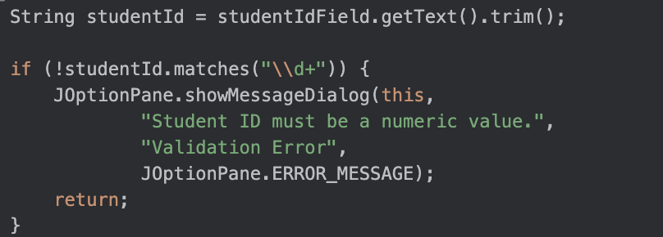

6.1.2 Loading Feedback and Button Locking
Before:

After:

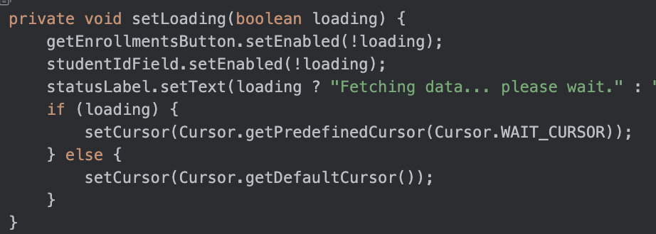

6.1.3 Read-Only Results Table

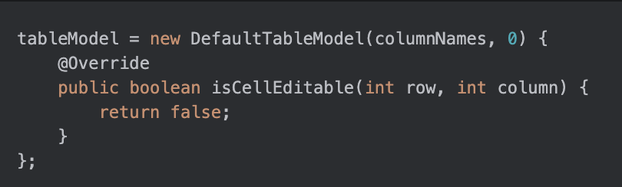

6.1.4 GUI Evidence

- LMS desktop application on startup
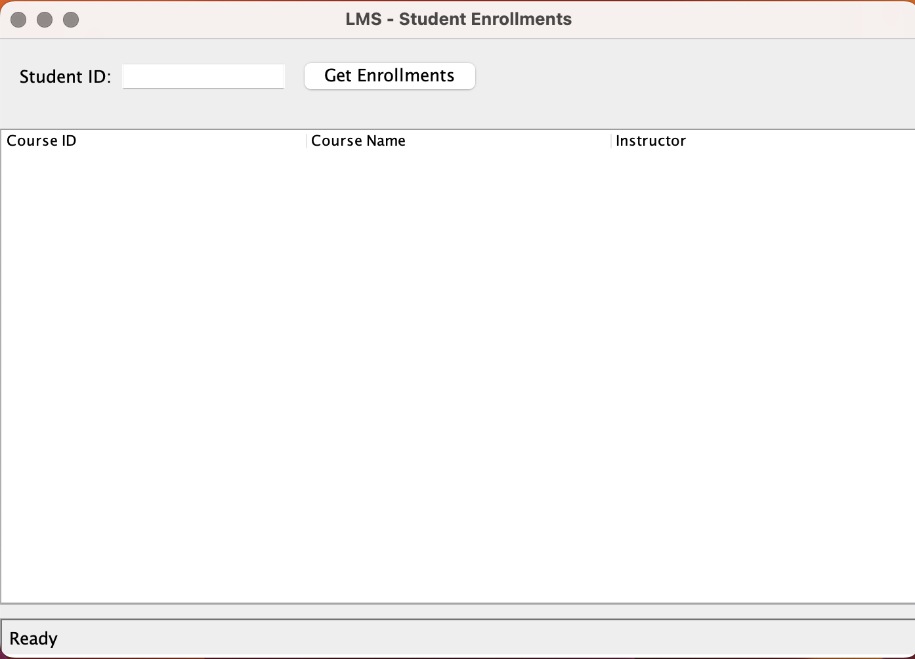

- Successful enrollment retrieval for student 10
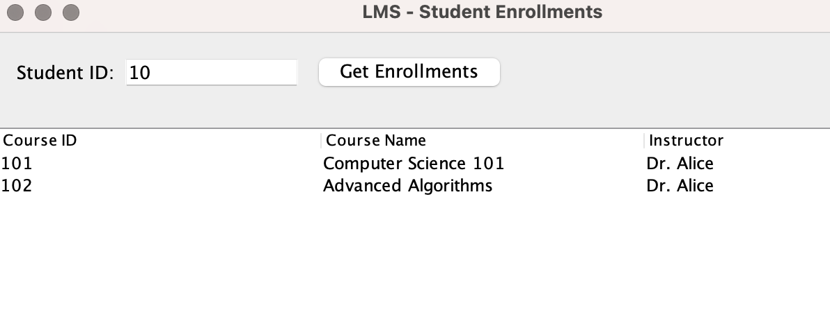
- Validation feedback for non-numeric input
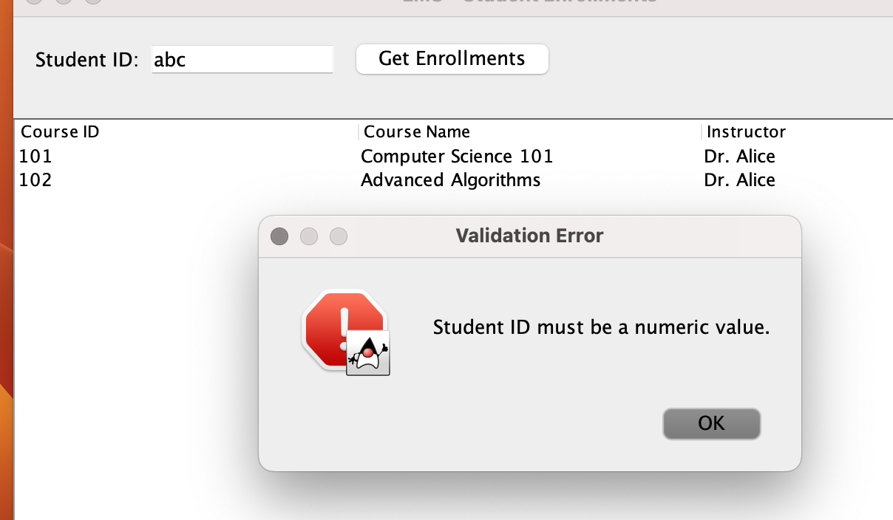

- Empty result state for student with no enrollments
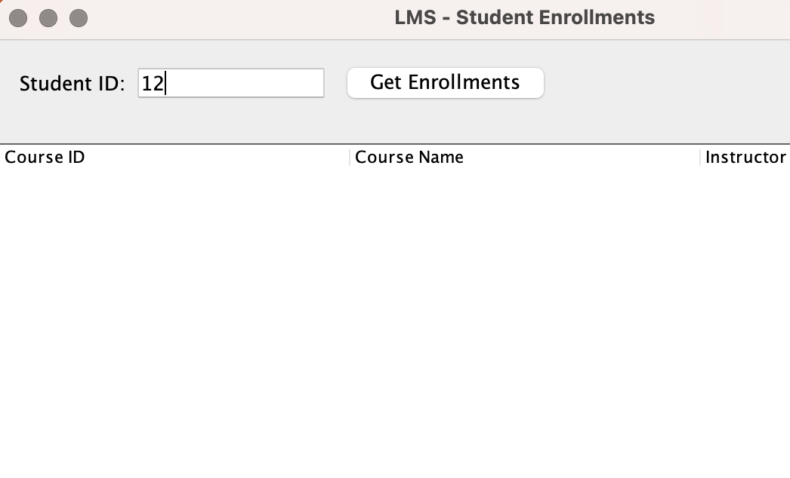

- Error handling when backend service is unavailable

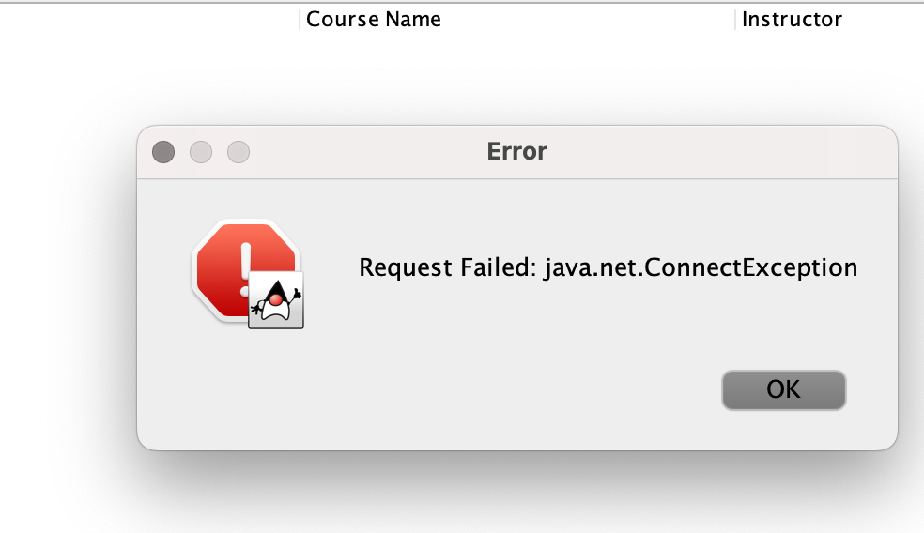
7.0 Methodology

7.1 Tools

- Java 17
- Spring Boot 3.2.3
- Java Swing
- Maven multi-module build
- JUnit 5
- Mockito
- Spring Boot Test
- JaCoCo
- IntelliJ IDEA

7.2 Development Practice

The project helps us to understand more of the good software engineering practices which complement its overall good quality, maintainability, and reliability. One of its main benefits is a modular bifurcation between the backend and frontend parts of the code, which allows each part of the system to be developed, tested, and maintained separately. This segregation is reinforced with structure such as layered application architecture in the backend where the responsibilities are clearly divided between the controller, service and repository layers (Deljouyi, 2023). This way, it makes the code more understandable and reduces coupling between the code components.

An appropriate next step to improve the project would be instituting proper version control using Git that includes the use of branches and a proper commit history to efficaciously manage which changes of the development. Furthermore, combining a CI/CD pipeline with tools like GitHub Actions or GitLab CI would make it easier to assume the function of running the test suite for each commit / pull request (be in the form of calling mvn test), which would ensure the code quality verification process is continuous. JaCoCo coverage reports could also be published as build artefacts, which would provide visibility into the test coverage over time.

8.0 Conclusion

In summary, the Learning Management System (LMS) project is a great example of making effective use of the fundamental principles of software engineering through modular design and layering. The system is structured, maintainable and comprehensible with a clear demarcation between components.

A salient strength of the project is its complete testing regime composed by unit tests, integration tests and system tests, supported by extensive code coverage. This creates a confidence in the correctness and reliability of the system. In addition, there are increases to usability inside the desktop application which further increase user experience.

Despite achieving the goals set by the project, it is limited for a lack of data persistence mechanisms, security features, and CI/CD integration. These gaps are the ways forward for future development.

Overall, the project is a testimony to good software engineering practice, and provides a good foundation upon which to build a better version.

Reference

Deljouyi, A., Koohestani, R., Izadi, M., & Zaidman, A. (2025). Leveraging Large Language Models for Enhancing the Understandability of Generated Unit Tests. Leveraging Large Language Models for Enhancing the Understandability of Generated Unit Tests, 1449–1461. https://doi.org/10.1109/icse55347.2025.00032
Dinella, E., Ryan, G., Mytkowicz, T., & Lahiri, S. K. (2022). TOGA. Proceedings of the 44th International Conference on Software Engineering, 2130–2141. https://doi.org/10.1145/3510003.3510141
Yuan, Z., Liu, M., Ding, S., Wang, K., Chen, Y., Peng, X., & Lou, Y. (2024). Evaluating and improving ChatGPT for unit test generation. Proceedings of the ACM on Software Engineering., 1(FSE), 1703–1726. https://doi.org/10.1145/3660783

